Bioc 404 March 1st, 2006

The website for this class is www.mcgnmr.ca/kalle/404.

Last class we talked about the theory of mass spectrometry. Today we will cover the different types of mass spectrometers and how they accomplish these 4 steps: volatilization, ionization, separation, and detection.

As a side note, Miliken’s oil drop experiment used an atomizer to form oil drops and then used an x-ray source to ionize the sample. So even in those days, the four core steps for mass spectrometry were employed.

There are many types of mass spectrometers, but they can generally be separated in 2 different classes: how you volatilize and ionize the sample, and how you separate and measure the mass.

Methods of volatilization:

- Electron Ionization (EI) works by directly ionizing the samples in a vacuum with an electron beam. This is the oldest technique and also the harshest because it tends to damage/fragment the sample. It is a good ionization method for small molecular weight compounds (less than 400Da) or when fragmentation of the sample is desired to get a collection of mass/charge ratios so as to better identify the sample’s composition. It may also aid in differentiating molecules of same molecular weight or of different chemical structures since their fragmentation patterns are distinct. It is however not useful for proteins because too many fragments are obtained. This technique is very sensitive and can give high-resolution spectra, due to the fact that the experiment is conducted under high vacuum. This is done to prevent the sample molecules from colliding with other gas molecules and causing them to scatter around the chamber, making it harder to measure and resulting in a lower resolution.

- Fast Atom/Ion Bombardment (FAB) uses an atom or ion beam (Argon or Cesium ions) instead of an electron beam to ionize the sample. It requires that the sample be in a small volume of matrix to desorb the ions. This technique causes less fragmentation because the particles are larger and not as strongly ionizing and therefore don’t break the sample as much as in EI. This means that larger molecular weight compounds can be analyzed (approximately 7kDa). FAB is also very sensitive and can be coupled to high-resolution mass spectrometry because the ionization is held in a high vacuum.

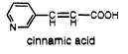
- Matrix-Assisted Laser Desorption/Ionization (MALDI) is a technique suitable for proteins. It uses a laser and requires that the sample be in a UV absorbing matrix, the most common one being cinnamic acid whose conjugated ring absorbs in the UV region.
The matrix absorbs the photons emitted by the laser and heats up, causing the sample to ionize. This is a very soft volatilization technique since the laser doesn’t directly ionize the sample. Along with the 2 previous methods, MALDI requires a high vacuum and can be coupled to a high-resolution mass spectrometer. It can also tolerate the presence of salts, which causes lots of problems in other techniques, especially electrospray ionization. MALDI however has lower sensitivity because the sample is diluted in the matrix.
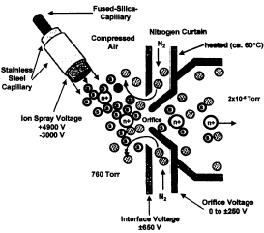
- Electrospray Ionization (ESI) is also used for proteins and is essentially the same as Miliken’s experiment. It is the softest ionization method because there is no heating up. It basically consists of an atomizer that sprays droplets of the sample and whose needle is held at an electric potential (usually 2000-3000 volts) to charge the droplets. These droplets then pass through a stream of dry gas such as nitrogen to remove any water molecules that may contaminate the vacuum. As the drop dries down, the surface charge (the charge on the drop) increases because the surface area decreases while the total charge remains the same, and repulsion between the charges of the droplet begins to occur. Eventually, the droplet will collapse because the surface tension is weaker than the electrostatic repulsion– this is called the coulombic explosion. This is how one can go from a drop that contains millions of molecules to a single protein. Finally, the particles go through a very small orifice into the high vacuum chamber for separation and detection.

This technique suffers from the fact that the ionization step doesn’t already take place in a vacuum, in contrast with the other 3 techniques. ESI also has difficulties when salts are present in the sample. Another phenomenon that arises with this method is multiple charging, where particles can have more than one charge on them, sometimes up to 20 or 30 charges. A disadvantage to this is that lots of peaks show up on the spectrum, which makes it difficult to determine the correct mass of the compound. On the other hand, multiple charging can increase the detection range for peptides. For example, a detector that works with a separation range of 100-3000 mass/charges doesn’t allow one to study proteins because it would only measure peptides up to 25-28 residues (remember: 1 amino acid ~ 110da, 1 nucleotide ~330da and 1base pair ~ 660da). Coupling a separation technique with multiple charging allows one to analyze a peptide up to 60kDa.

Methods of separation:


- Fourier-Transform (FT) or Cyclotron Resonator consist of a charged particle moving in a magnetic field and feeling a force (F) = ze ⋅ (v x B) where (ze) is the ion charge, v is the speed of the particle, and B is the strength of direction of the magnetic field. The direction of the force is dictated by the vector cross product of v with B. This force will push the particle to move in a circular motion with radius
Cyclotron resonator
+
(r) = (v/eB) ⋅ (m/z) = (2ΔV/eB²)^{1/2} ⋅ (m/z)^{1/2} and frequency
(ν) = (1/2π) ⋅ (1/eB) ⋅ (z/m), where ΔV is the electric potential and m is the mass of the particle. This is called a cyclotron and when it sends out a cluster of particles, it becomes a synchrotron. With this method, the frequency can be used to accurately determine the particle mass. FT is a very expensive technique and has very high resolution, allowing one to establish the elemental composition of the molecule.

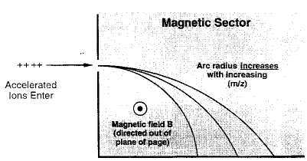
- Magnetic Sector is the exact same method of separation as the cyclotron resonator, except that it does not cycle completely around but rather stops at a certain point. With this technique, the mass of particle is determined from the radius.

Multiple detectors can be used with both of these methods to measure where the particle lands. This is done by sweeping the magnetic field over the detectors, which will give a signal for every particle that enters the instrument and result in high sensitivity. The only downside to this is that the number of detectors needed increases the cost.
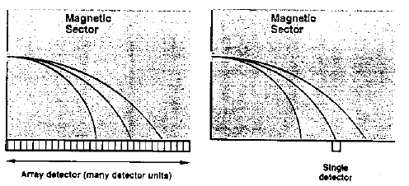
Measurements of the mass may also be taken with a single detector by changing the magnetic field to generate a spectrum since the equations depend linearly on the magnetic field. This is less expensive, but limits the range to the single detector. An alternative to changing the magnetic field is to sweep the velocity of the particle since all of the equations also depend on the velocity of the particle for the magnetic sector.

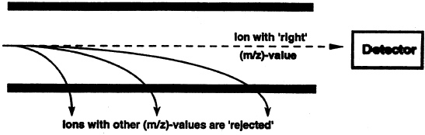
- Quadrupole Filters use radio frequency electric fields to attract and repel the particles to the electrodes, causing them to oscillate. By controlling the feed of particles, the charge, the frequency and the voltage, you can select for particles that have the desired mass/charge ratios. This technique suffers from low sensitivity because most of your particles are not going to make it through to the detector. On the other hand, it also has a good resolution over relatively short ranges and works well with low vacuum. So these types of instruments are commonly coupled with ESI where you have a bad vacuum because of the ionization. The quadrupole filters method is also much more cost-effective than the other separation techniques.

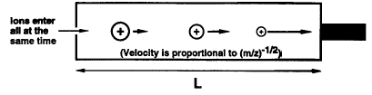
- Time of Flight (TOF) basically measure how fast a particle is moving. It functions by accelerating a charged molecule through a voltage and measuring its velocity, which is related to the mass/charge ratio. The particles with lots of charges and little mass are accelerated faster and will reach the detector first, whereas the particles with fewer charges or lots of mass are going to reach there last. A condition for measuring the velocity of multiple particles with this technique is that all the particles must start at the same time. This can be achieved by coupling it with MALDI, which uses a laser to ionize the sample. Since the laser pulse can be very short, the particles essentially leave simultaneously. There are now lots of derivatives of the MALDI-TOF instruments, such as adding a little electrostatic mirror at the end of the tube so that the particles bounce back. More accuracy is obtained this way.
Advances in the field have now allowed TOF to be coupled with ESI, which was not possible before because the particles would be continuously entering the TOF chamber. Now, these instruments have little traps so that you collect your ions from your ESI and start them off at the same time.

The most common ionization techniques are MALDI and the ESI, while the most frequent separation methods are the quadrupole filters, TOF and the Fournier transform, which remains the most high-resolution technique.

In Friday’s lecture, we will look more closely at ESI spectra of small proteins, whose peaks all have the same mass, but have different charge ratios. This is not exactly true; there is a difference in mass in adjacent peaks due to the fact that a peak has to have a different number of electrons or protons in order to have a different charge. So what we will see on Friday is that there is a formula that allows you to predict the peak position and exact mass of a charged particle. We will also see examples of what happens when you have salt in your spectra. Instead of adding a proton, you get the protein plus an extra sodium ion, while the protons make the solution acidic. This is why you have to avoid salts when you study mass spectrometry.

